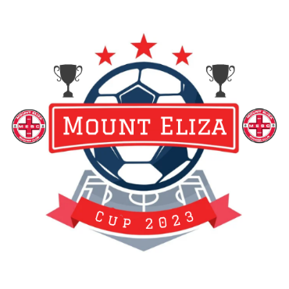

Welcome to the MESC Cup/Shield 2023
Competition Format
Each team will play a minimum of three games against teams in their age group/graded pool. All games including finals will be played on the same day.
Boys
7 v 7 games played on a Quarter Pitch
Ages U7s, U8s and 9s will not be graded,
Please review registration link for available places.
Boys
9 v 9 games played on a Half Pitch
Ages U10s U11s and U12s, teams will be graded as below.
Premiers Cup for Kangaroos Teams – max 8 teams, 2 groups of 4
Champions Cup for Wallabies and Joeys Teams – max 8 teams, 2 groups of 4
Age U13s
Champions Cup for B C and D grade teams – max 8 teams, 2 group of 4
Boys
11v11 games played on a Full Pitch
Ages U14s and U15s
Champions Cup for B C and D grade teams – max 8 teams, 2 group of 4

Girls
7 v 7 games played on a Quarter Pitch
Ages U7/8s and U9s will not be graded - max 8 teams per age group, 2 groups of 4
Girls
9v9 games played on a Half Pitch
Ages U10s/U11s/U12s and U13s, teams will be graded as below.
Champions Cup - max 8 teams per age group, 2 groups of 4
(competition may be split into two graded leagues, subject to registration)
Girls
11v11 games played on Full Pitch
Ages U14s, U15s and U16s
Champions Cup for B C and D grade teams – max 8 teams, 2 group of 4
(Subject to registrations group numbers could change)

